Member Protection Information Officer

Club Promotion Toolkit

Table of contents

MPIO Role Description 2

About the role 2

Knowledge and skills required 2

What the MPIO does 2

What the MPIO does not do 3

Training available for MPIOs 3

Club Templates 4

How to use these templates 4

MPIO Email Update 5

Website Article 6

Social Media Posts 7

Facebook/Twitter (X)/Threads 7

Instagram 8

Customising Your MPIO Poster and Social Tiles 9

Canva Instructions 9

# MPIO Role Description

## About the role

Member Protection Information Officers (MPIOs) are an integral part of all levels of Australia sport, especially grassroots sport. MPIOs are there to listen to issues raised by members of any sport before triaging and referring them to the right place to find a resolution.

The MPIO is responsible for providing information about a person's rights, responsibilities and options to an individual or group making a complaint or raising a concern that occurs in the context of sport.

The training available and suggested activities for MPIOs is applicable to and can complement the role of Child Safety Officers.

## Knowledge and skills required

There are no pre-requisites to becoming an MPIO. Anyone with an interest in helping their sporting organisation be safe and inclusive can become an MPIO. Tips for recruiting or appointing an MPIO include:

* Where feasible, appoint two people to share the role and provide multiple contact points for members.
* Look for volunteers with professional skillsets that will help them adapt quickly to the role.
* Appoint persons with strong listening and empathy skills and an ability to form empowering, respectful relationships with parents, children and young people, and other volunteers.
* Avoid appointing individuals who may have conflicts of interest or who work very closely with participants (e.g. coaches).

## What the MPIO does

* Understands the current landscape for member protection and child safeguarding policies in sport.
* Understands if their organisation has adopted the National Integrity Framework (NIF), and
  + if YES, understands relevant NIF policies and the complaint handling options and contact details for their sport.
  + if NO, understands the relevant sport policies and complaint handling options and contact details for their sport.
* Has the contact details for the relevant National Integrity Manager for their sport, or relevant persons in authority for complaint handling for their organisation.
* Distributes resources in the club to raise awareness of relevant member protection and child safeguarding policies.
* Acts as a trusted person for club members to share disclosures or allegations of prohibited conduct.
* Validates feelings and provides options for wellbeing support.
* Supports persons making complaints to identify the right reporting channels and contacts available to them.
* As required, shares information with relevant authorities or persons managing complaints in accordance with confidentiality and privacy principles.
* Helps promote an inclusive, safe, fair environment in the club.

## What the MPIO does not do

The MPIO does not:

* Manage any aspects of a complaint process, this includes not doing any of the following:
  + Assessing if a complaint meets the required thresholds for prohibited conduct under a relevant policy.
  + Making a judgment about whether the allegation brought forward is vexatious (knowingly false or untrue) .
  + Conducting a risk assessment about threats to safety or temporarily standing down individuals complained about.
  + Conducting any form of investigation.
  + Acting as a panel member on a tribunal hearing.
  + Applying or communicating sanctions to a respondent to a complaint.
* Advocate on behalf of a complainant during investigations or hearings.
* Share information about complaints, or discuss complaints, with anyone other than the person complaining, relevant authorities or persons managing complaints.
* Provide any form of legal counsel or advice.

## Training available for MPIOs

To gain recognition as a qualified MPIO, people must complete:

1. Part 1: the MPIO Online course on [SIA EDGE](https://elearning.sportintegrity.gov.au/user_login), the shared Play by the Rules / Sport Integrity Australia eLearning platform.
2. Part 2: a training session (face to face and online available) provided by your relevant state/territory government department of sport, peak body for sport, national sporting organisation, state sporting organisation or local government.

Additional training and support available for MPIOs includes:

* Online courses on [SIA EDGE](https://elearning.sportintegrity.gov.au/user_login), the shared Play by the Rules / Sport Integrity Australia eLearning platform.
  + Safeguarding Children and Young People in Sport Induction.
  + Safeguarding Recruitment and Screening.
  + National Integrity Framework.
  + Harassment and Discrimination.
  + PBTR – LGBTQIA+ Inclusive Clubs.
* MPIO networks through state sport and recreation governing bodies
* SSO/NSO MPIO contacts and club support contacts.

# Club Templates

## How to use these templates

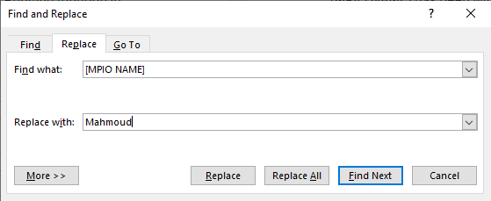Replace all text in [brackets] with the appropriate details. To make it easier, you can use the Replace function in Microsoft Word (Ctrl + h) or the Find and Replace function in Google Docs (Ctrl + f):

The brackets you’ll need to replace across all templates are:

[CLUB NAME]

[MPIO FULL NAME]

[MPIO NAME]

[DATE JOINED]

[CLUB SUPPLIED PHONE NUMBER]

[CLUB BASED EMAIL]

[WEB ADDRESS]

[SIGNATURE OF YOUR CLUB EXECUTIVE]

**NB:** Please make sure you include the brackets when you’re searching for text to replace to avoid replacing other instances of the word in the templates.

## MPIO Email Update

*You can edit this template at your discretion. It can be emailed to members or posted in online groups.*

**Subject:** Meet your MPIO

Hi Everyone

I’d like to introduce you to our Member Protection Information Officer (MPIO), [MPIO FULL NAME].

[MPIO NAME] has been with [CLUB NAME] since [DATE JOINED]. They have completed their MPIO training and are ready to help make our club more inclusive, safe, and fair.

[CLUB NAME] has a zero-tolerance policy for any kind of abuse, bullying, harassment or discrimination. The safety of participants, volunteers and officials is central to our goal to provide enjoyable and rewarding experiences.

If anything happens to you, or you see or hear something that doesn’t seem OK, [MPIO NAME] can listen to you, triage problems, and help you find the right place to resolve any issues you may have, whether it’s lodging a complaint or checking on your rights and responsibilities as a member of our sport.

You can chat about club-related issues with [MPIO NAME] if you see them at the club, or you can contact them via the details below:

Phone: [CLUB SUPPLIED PHONE NUMBER]

Email: [CLUB BASED EMAIL]

If you have any questions, please reach out to [MPIO NAME] or me.

Kind regards

[SIGNATURE OF YOUR CLUB EXECUTIVE]

## Website Article

Example web article or blog post:

Member Protection Information Officers (MPIOs) have long been a part of Australian sport, creating positive club environments and supporting inclusive, safe, and fair sport. MPIOs listen to issues that club members may be going through and refer them to the right place to find a solution.

What is an MPIO?

MPIOs are there to listen to issues raised by members of any sport before triaging and referring them to the right place to find a resolution. The MPIO is responsible for providing information about a person's rights, responsibilities and options to an individual making a complaint or raising a concern, as well as information support during the process.

MPIOs don’t handle complaints or investigate grievances, and they don’t mediate between members or stakeholders. They’re also separate from the relevant Integrity Manager or the person(s) in authority regarding complaints, disputes, and resolutions in our sport. MPIOs are an impartial party who are there to help guide people in the right direction.

The MPIO at [CLUB NAME] is [MPIO FULL NAME]. You can talk to them directly at the club or contact them via [CLUB SUPPLIED PHONE NUMBER] or [CLUB BASED EMAIL] to discuss club-related issues.

To find out more about MPIOs you can visit the Play by the Rules website at [www.playbytherules.net.au/mpio](http://www.playbytherules.net.au/mpio).

## Social Media Posts

You can use our pre-made MPIO social media tiles or make your own to share with the example text below.

### Facebook/Twitter (X)/Threads

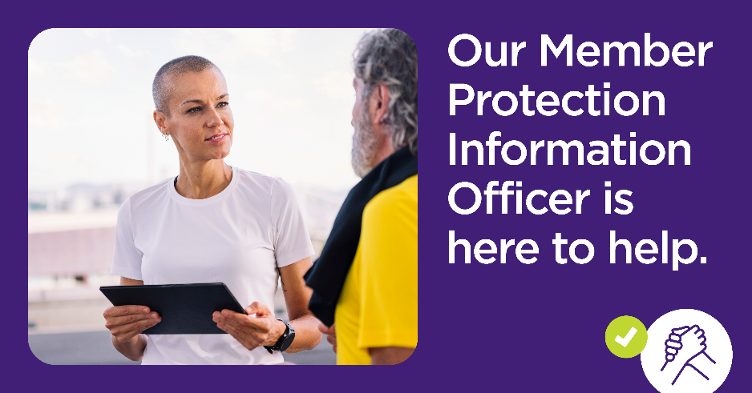The image template can be downloaded from [www.playbytherules.net.au/mpio](http://www.playbytherules.net.au/mpio)

*Example of a social tile at 1080px by 566px*

**Post 1**

One way we support inclusive, safe, and fair sport at [CLUB NAME] is by having a Member Protection Information Officer (MPIO) as a part of our team. MPIOs listen to issues and refer club members to the right place to get an outcome. Learn more about our MPIO and how they can help you on our website [WEB ADDRESS]

#MPIO #InclusiveSafeAndFairSport

**Post 2**

Do you know what to do or where to go if you have an issue? A good option is to chat with our Member Protection Information Officer (MPIO) [MPIO NAME]. Find out what they can do to help you by visiting our website [WEB ADDRESS]

#MPIO #InclusiveSafeAndFairSport

### Instagram

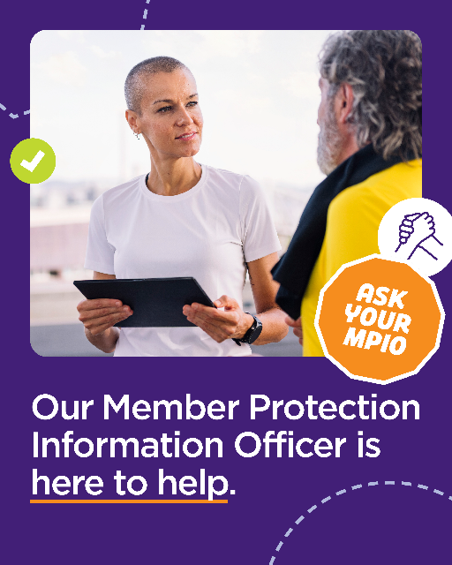The image template can be downloaded from [www.playbytherules.net.au/mpio](http://www.playbytherules.net.au/mpio)

*Example of a social tile at 1080px by 1350px*

**Post 3**

One way we support inclusive, safe, and fair sport at [CLUB NAME] is by having a Member Protection Information Officer (MPIO) as a part of our team. MPIOs listen to issues and refer club members to the right place to get an outcome. Learn more about our MPIO and how they can help you via our bio ☝

#MPIO #InclusiveSafeAndFairSport

**Post 4**

Do you know what to do or where to go if you have an issue? A good option is to chat with our Member Protection Information Officer (MPIO) [MPIO NAME]. Find out what they can do to help you via our bio ☝

#MPIO #InclusiveSafeAndFairSport

# Customising Your MPIO Poster and Social Tiles

You can download the social tiles from earlier in this document and the A4 size poster from [www.playbytherules.net.au/mpio](http://www.playbytherules.net.au/mpio) and edit it in a free graphic design tool like Canva, or in a professional program like Adobe Photoshop, before you send it off to be printed.

## Canva Instructions

#### Step 1

Go to [www.canva.com](http://www.canva.com) and log in to your account. Once logged in, click on ‘Create a Design’ and select ‘Flyer (A4 21 x 29.7 cm)’.

#### Step 2

In the menu on the left side of the page, select ‘Upload’ then upload the ‘P250714_POSA4.png’ poster and a high resolution (at least 1080p and 72dpi, or big enough that it doesn’t look blurry or pixelated when you put it in Canva) photo of your MPIO, club, or another image that you’d like to use.

#### Step 3

Click on the poster image and move it on the canvas to fill the space. Once it’s where you want it, click on your insert photo in the ‘Upload’ menu, re-size it to cover the top part of the page (so you can no longer see the ‘pebble’ element).

#### Step 4

With the photo selected (there will be a purple border around it), the Edit bar menu will appear at the top of the artboard. Click on the ‘Position’ button and the left menu will appear. Click on the ‘To back’ option.

#### Step 5

In the left menu, select ‘Text’ then press the purple ‘Add a text box’ button. A text box will appear on your poster. Enter your name and move it to the white bar under the ‘I’m your MPIO’ text. You can change the font with the menu at the top of the artboard.

#### Step 6

To download and print, click on the ‘Share’ button in the top right of the page, then select ‘Download’. In the ‘Download’ menu, go to the File Type drop-down menu and choose a file that works for you (‘PDF standard’ if you want to email it, ‘PDF Print’ if you want to take it to your local print shop to make posters) then click ‘Download’.

#### Step 7

You’re done! Enjoy promoting your MPIO role in your club.